GL 220 Cheat Sheet
The GL220 gives general ledger detail of a particular department and account number.
In the green screen, enter “GL220”. You should receive a screen similar to this.
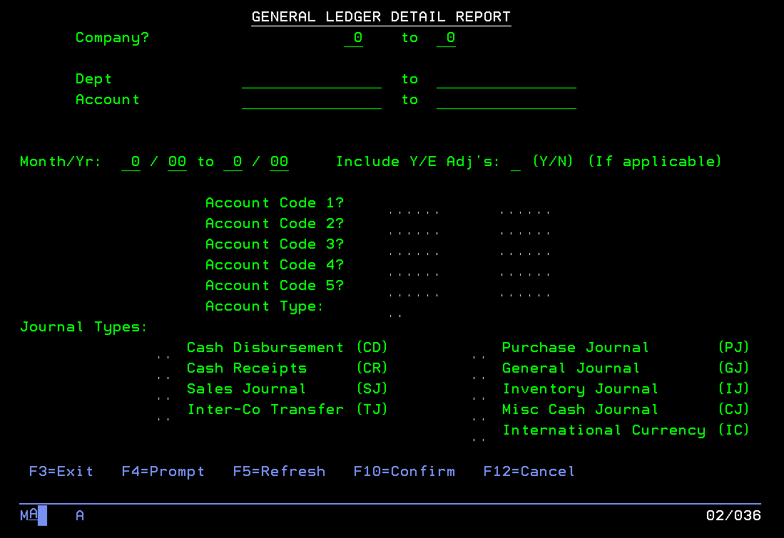
Input the following:
Company: This will ALWAYS be 01 to 01.
Dept: This will be whichever department string you want to run. For example, to run only interior, you would select 0071 to 0071 (must be 4 digits – BTL you will be 03XX, PVU – 06XX). You could also select a string of departments, if you selected 0070 to 0072, this would generate engineering, interior, and install. However, you will only be able to generate departments you have authority to.
Account: This can be found via a chart of accounts (accounting can provide). This can be a chain of accounts, or one singular account. For example, on the next snip, I generated all office supply accounts (which I found via GL121).
Month/Yr: This will be for whichever time period you would like to see detail for. It can be a specific month or several months. However, you cannot run it across calendar years.
Include Y/E Adj’s: You may leave this blank.
This is all the basic inputs for this screen. I’ve provided an example of a completed screen on the next snip.
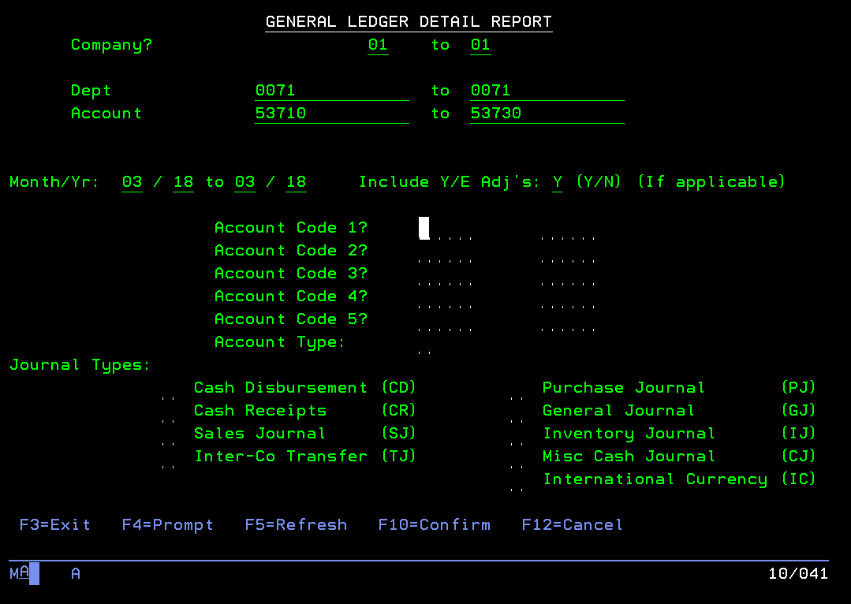
Hit F10 to jump to the next screen. You will receive the following screen.
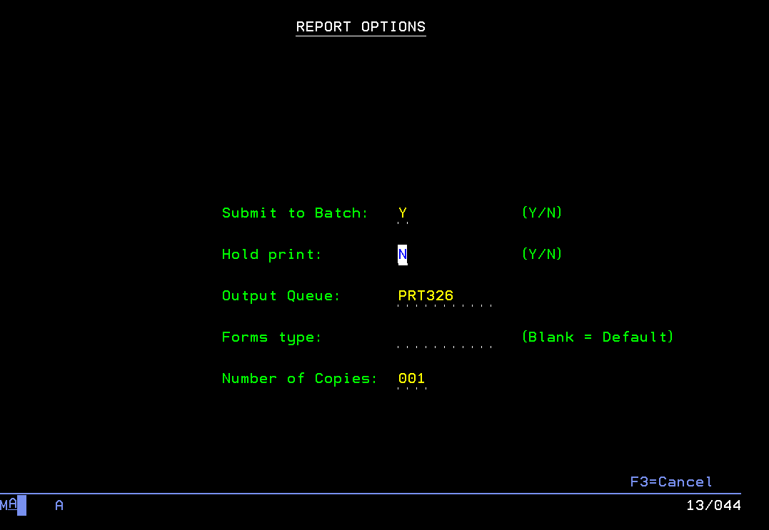
From here, make sure “Submit to Batch” is marked “Y” and “Hold print” is marked “N”. This should already be your default.
Only input that should be needed here is the “Output Queue”. This should default to be your home department printer, however, you may change it to be sent to your email in text or pdf format. The commands for this are “EMAIL2TXT” or “EMAIL2PDF”.
The report should be generated.
See the next snip for what the output looks like.
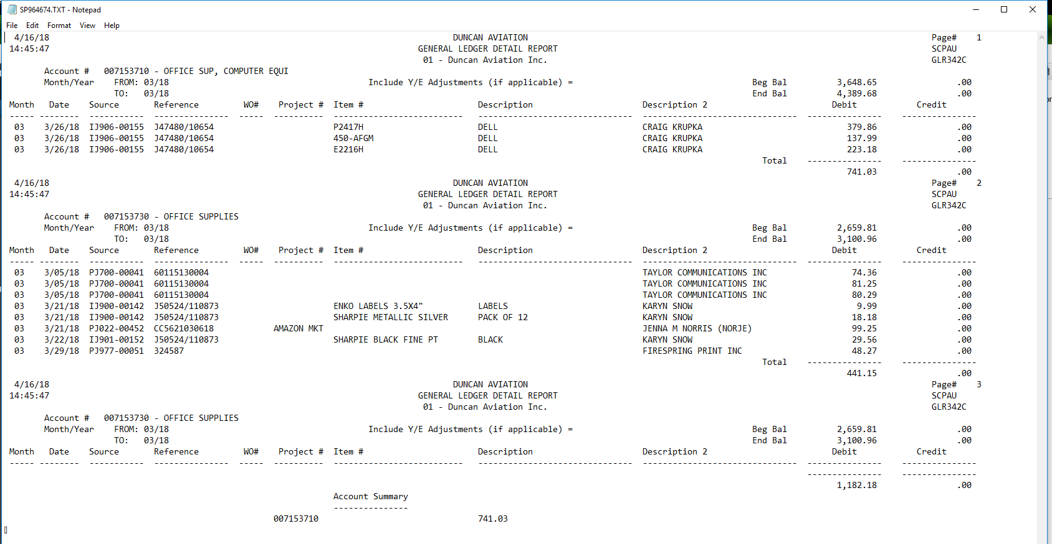
General information on this report is as follows.
Beg Bal: This will give you the YTD balance at the beginning of the month requested.
End Bal: This will give you the balance at the end of the month for the time period requested.
Source: This is how this entry came to be. The start of it is the most important.
- PJ is purchase journal (from matched invoices, generally non-PO items)
- IJ is inventory journal (this was anything where a PO was cut, primarily inventory).
- CR is credit journal (this is from cash receipts)
- SJ is sales journal (this comes from billings)
- GJ is a general journal (this will be an entry made by Jamie, Jacquie or Paul)
Reference: This will generally be a purchase order reference for IJ sources, vendor invoice number for PJ sources, or Duncan’s invoice number for SJ sources.
WO#: For sales journal items, this will either be a work order or order number.
Project: This will generally be a purchase order number.
Item: This will give the inventory item number.
Description: This field will often be blank, generally gives additional information.
Description 2: This field provides the vendor name or additional information.
Debit: If an amount is listed in the debit column, generally considered a cost of sale or an expense, which will decrease your gross profit or decrease your net income.
Credit: If an amount is listed in the credit column, it increases your gross profit or increases your net income.
**General guideline: If you see something in your department that shouldn’t be there, we can move it via a general journal entry. If we need to get something moved, contact Paul Schlorholtz, Controller, or Jacquie Rowan, Accounting Manager, and we can get it moved. Please consider materiality in these situations. In general, we should try to figure out how it got posted there and why to make sure it doesn’t continue.

